Administering and Interpreting Instant Saliva Drug Tests

- Donor should not place anything in mouth 10 minutes prior to test.

- The donor should close their mouth around the sponge and move the sponge around for saliva collection for about 1-3 minutes until sponge is soft and fully saturated. No hard spots should be felt on the sponge when it is fully saturated.

- The collection sponge is placed in the device, the device should be placed on a flat surface so that the saliva is distributed evenly to all test strips.

- There must always be a line beside the C (control) – This tells us that the device worked properly. If no line is present, then the device is defective and the test invalid.

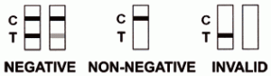

- A line beside the T (test) means the donor is negative for the corresponding drug. After waiting the amount of time prescribed by the manufacturer, a line beside the T, no matter how faint, is a negative result. It is important not to infer anything beyond this. Whenever there is question, ask another trained collector to take a look, preferably without the donor’s input. Sometimes placing something over the strips to the right and left of the one in question can help.

- No line beside the T(test) means the test is positive…but ONLY when there’s also a line beside the C.
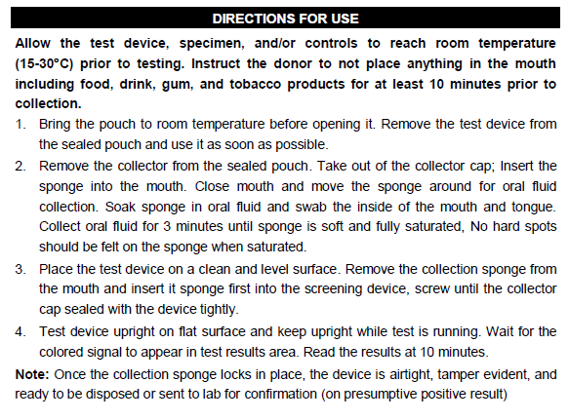
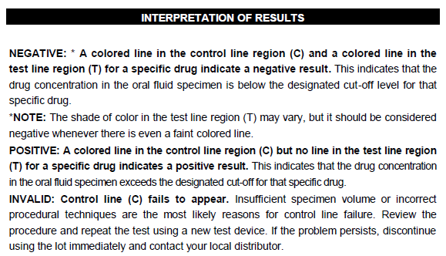
*The device instructions refer to “screwing” the cap on and a locking interface. The lid simply pushes on. I’m not sure why it is worded this way.

